JAVA PROGRM-BALANCED BRAKET

**package** pppp;

**import** java.util.Scanner;

**import** java.util.Stack;

**public** **class** Expression {

**public** **static** **void** main(String[] args) {

**boolean** flag =**false**;

Stack<Character> input = **new** Stack<Character>();

System.***out***.println("Enter your String to check:");

Scanner scanner = **new** Scanner(System.***in***);

String sinput = scanner.nextLine();

**char**[] c = **new** **char**[15];

c = sinput.toCharArray();

**for** (**int** i = 0; i < c.length; i++) {

**if** (c[i] == '{' || c[i] == '(' || c[i] == '[')

input.push(c[i]);

**else** **if** (c[i] == ']') {

**if** (input.pop() == '[') {

flag = **true**;

**continue**;

} **else** {

flag = **false**;

**break**;

}

} **else** **if** (c[i] == ')') {

**if** (input.pop() == '(') {

flag = **true**;

**continue**;

} **else** {

flag = **false**;

**break**;

}

} **else** **if** (c[i] == '}') {

**if** (input.pop() == '{') {

flag = **true**;

**continue**;

} **else** {

flag = **false**;

**break**;

}

}

}

**if** (flag == **true**)

System.***out***.println("balanced");

**else**

System.***out***.println("Unbalanced");

scanner.close();

}

}

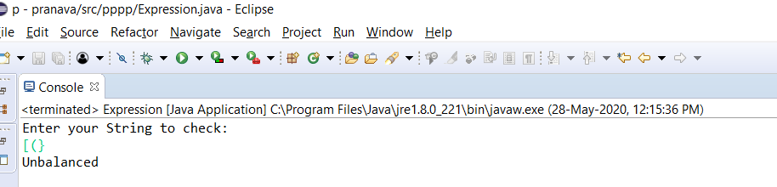Output

